**2025 Rate Manual –** **Greeley Water & Sewer**

**Table of Contents**

|  |  |
| --- | --- |
| **Water Fees and Charges** | **3** |
| **WaterSmart** | **4** |
| **Wastewater Fees and Charges** | **5** |
| **Watering Violation Fines** | **6** |
| **Stormwater** | **7** |
| **Development** | **8** |
| **Cash-In-Lieu** | **8** |
| **Fire Hydrant Meters and Bulk Water Stations** | **9** |
|  |  |
| **Milton Seaman Reservoir Photo Courtesy of Dennis Margheim C.W.P.** |  |

**Rates and Fees**

The Greeley Water and Sewer Department works to keep costs as low as possible while doing what is necessary to provide our community with a secure and reliable supply of water and sewer services. Greeley Water and Sewer is a user-pay enterprise. This means that all of the money we have to spend on our system comes from what our customers pay us in water fees and what developers pay us to tap into our system. No tax revenues go to the water or sewer system. Below is an explanation of Greeley’s monthly water and sanitary sewer rates.

Greeley’s water and sewer customers are billed every month. Your monthly bill consists of fixed service and consumption charges for every 1,000 gallons of water used or sewage treated. Sewer charges vary based on customer classes or how much system capacity the customer uses. For instance, a restaurant creates a larger impact on the wastewater treatment and reclamation facility (WTRF) than a single-family residence does and, therefore, pays a higher rate. Water customers who are outside the city limits pay a higher rate for service because they did not help pay for the original system construction.

**Water Fees and Charges**

**Water Use Charge is per 1000 gallons.**

**Single-Family Residential Water Budget (Inside City Limits)**

|  |  |
| --- | --- |
| Tier 1 (<= 100% of Water Budget) | $5.94 |
| Tier 2 (101-130% of Water Budget) | $6.88 |
| Tier 3 (131-150% of Water Budget) | $9.38 |
| Tier 4 (> 151% of Water Budget) | $12.51 |

**Non-Water Budget Rates (Inside City Limits)**

|  |  |
| --- | --- |
| Residential not on Water Budget | $6.22 |
| Commercial | $6.03 |
| Industrial | $4.97 |
| Non-Potable Service | $4.35 |

**Non-Water Budget Rates (Outside City Limits)**

|  |  |
| --- | --- |
| Residential | $12.34 |
| Commercial | $12.34 |

**Fixed Monthly Water Service Charge**

|  |  |
| --- | --- |
| **Meter Size** |  |
| 3/4" or 5/8" | $19.00 |
| 1" | $19.65 |
| 1 1/2" | $26.50 |
| 2” | $29.30 |
| 3” | $87.50 |
| 4” | $102.50 |
| 6” | $130.00 |
| 8” | $166.20 |
| 10” | $214.05 |
| 12” | $276.95 |
|  |  |
| Non-Potable Service |  |
| All meter sizes | $19.00* |
| *Only charged in months that service is active |  |
|  |  |
|  |  |

**Misc Fees and charges:**

**Tampering fee:** Assessed when water or sewer assets are tampered with or damaged by a customer. **$200.00**

**Turn-On Charge:** Minimum turn-on charge is applicable to all turn-ons, including but not limited to: non-payment shut-off & turn-on, emergency & non-emergency repairs (except in the case of meter failure or meter repair), lawn taps (except in the case of multiple lawn taps on the same property, only one charge will be required per service call).

|  |  |
| --- | --- |
| Non-potable | No Fee |
| Treated Water Minimum | $55.00 |

**Meter Failure water usage:** Charge will be based on average consumption for the same period in two prior years and billed at the then current rates.

**WaterSmart:**  **[Log on to WaterSmart](https://greeley.watersmart.com/)**

You can log on to the WaterSmart application to begin tracking your water use with your new smart meter. You will need your Greeley Water account number and your email address to get started.

**Wastewater Fees and Charges**

**The Fixed Monthly Service Fee for all classes is $19.00.**

**Wastewater Use Charge is per 1,000 gallons.**

**Commercial Sanitary Sewer Rates: Inside City, Per Sewer Connection**

|  |  |
| --- | --- |
| Class 1 | $4.63 |
| Class 2 | $6.56 |
| Class 3 | $8.48 |
| Class 4 | $10.40 |
| Class 5 | $12.35 |

**Commercial Sanitary Sewer Rates: Outside City, Per Sewer Connection**

|  |  |
| --- | --- |
| Class 1 | $6.23 |
| Class 2 | $8.54 |
| Class 3 | $10.89 |
| Class 4 | $13.03 |
| Class 5 | $14.72 |
| **Industrial Sanitary Sewer Rates:** |  |
| SIC 2013 – Prepared Food Manufacturers | $44.08 |
| SIC 2034 – Dehydrated Food Production | $8.71 |
| SIC 7218 – Industrial Laundries | $14.15 |
| SIC 2873 – Nitrogenous Fertilizer Producers | $74.48 |
| SIC 4212 – Transportation Equipment Services | $2.95 |
| SIC 2047 – Dog and Cat Food Manufacturers | $33.88 |
| SIC 5169 – Chemicals and Allied Products | $9.19 |
| SIC 7542 – Truck Washes | $9.70 |

**Residential Sanitary Sewer Rates (Inside City Limits)**

|  |  |
| --- | --- |
|  |  |
| Single Family Flat Rate: *Users not receiving city water: service charge plus kgal rate at 3,000 gallons* | $4.66 |
| Single Family Metered Rate: *Users receiving metered water: service charge plus rate/kgal of water use, not to exceed winter billing period consumption.* | $4.66 |
| Multi Family Flat Rate: *Users not receiving city water: service charge plus kgal rate at 12,000 gallons.* | $4.66 |
| Multi Family Metered Rate: Metered water users*: service charge plus rate/kgal of water use, not to exceed winter billing period consumption*. | $4.66 |

**Residential Sanitary Sewer Rates (Outside City Limits)**

|  |  |
| --- | --- |
|  |  |
| Single Family Rate Flat Rate: *For users not receiving city water: service charge plus kgal rate at 3,000 gallons* | $6.77 |
| Single Family Metered Rate: *For users receiving metered water: service charge plus rate/kgal of water use, not to exceed winter billing period consumption.* | $6.77 |
| Multi Family Flat Rate: *For users not receiving city water: service charge plus kgal rate at 12,000 gallons.* | $6.77 |
| Multi Family Metered Rate: Metered water users*: service charge plus rate/kgal of water use, not to exceed winter billing period consumption.* | $6.77 |

**\*Charges for residential customers are calculated on winter water use.**

**Residential Watering Violation Fines**

**First offense:** $100 fine

**Second offense:** $250 fine

**Third offense:** $500 fine

**Four or more:** $500 fine and customer pays for installing a flow restrictor to limit water use.

**Non-Residential Watering Violation Fines**

**First offense:** $200 fine

**Second offense:** $500 fine

**Third offense:** $1000 fine

**Four or more:** $1000 fine and customer pays for installing a flow restrictor to limit water use.

**There is no lawn watering between January 1 and April 14 without a variance.**

**Stormwater**

**Development Impact Fees**

Fees are recalculated annually using the Economic Adjustment Factor set out in Code 4.64.055

Impervious Area - $.29 per square foot. Fee is effective March 1st, 2025, through February 29th, 2026.

**Construction Drawing Review**

Staff review of construction drawings for development review applications or stand-alone applications.

$ 50.00 per sheet up to $ 1,000 maximum total.

**Stormwater Construction in the Public Right of Way**

|  |  |
| --- | --- |
| Tap Fee (each) | $132.03 |
| Floodplain Permit Fee - Subtype 1 (Floodplain use) | $100.00 |
| Floodplain Permit Fee – Subtype 2 (Flood Fringe Development) | $200.00 |
| Inlets (each) | $132.03 (Minimum $250.00) |
| Storm Main Line Construction | $3.31 Per Linear Foot (Minimum $250.00) |
| Detention Pond – Public or HOA | $594.11 |
| Detention Pond – Private | $594.11 |
| Concrete Drainage Channels and Pans | $0.27 per Linear Foot (Minimum $190.00) |
| Earth Channels | $0.21 per Linear Foot (Minimum $62.79) |
| Manholes | $66.01 each (Minimum $250.00) |
| Rip Rap Pads | $6.60 per Cubic Yard (Minimum $190.00) |
| Concrete Drainage Structure | $19.81 per Cubic Yard (Minimum $250.00) |
| Grading Permit | $600.00 plus $25.38 per acre and $150.00 Reapplication Fee (every 2 years) |
| **Misc Stormwater Fees** | **Amount** |
| Docket Fee-Administrative Hearings on Disputes. | $50.00 |
| Management Program Fee – charged on water & sewer bill and is based on the square footage of the property. | $0.00736742 per square foot |
| Inspection Fee: |  |
| Private Detention Pond MS4 Inspection | $100.00 |

**Development**

**Minimum Plant Investment Fees Based on Tap Size:** The following are minimum plant investment fees for treated water service to **nonresidential and multi-family residential lots**.

|  |  |  |  |  |
| --- | --- | --- | --- | --- |
|  |  | | **March 1, 2025 – Feb 28 2026** | |
| **Water Tap Size** |  |  | **Water PIF** | **Sewer PIF** |
| ¾” |  |  | $15,000.00 | $8,650.00 |
| 1” |  |  | $25,050.00 | $14,450.00 |
| 1.5” |  |  | $49,950.00 | $28,800.00 |
| 2” |  |  | $79,950.00 | $46,100.00 |
| 3” |  |  | $175,050.00 | $100,950.00 |
| 4” |  |  | $300,000.00 | $173,000.00 |
| 6” |  |  | $625,050.00 | $360,450.00 |

**Minimum Plant Investment Fees for Residential Lots:** The following are minimum plant investment fees for treated water service to single-family residential lots and multi-family residential lots on which each dwelling unit is serviced by a separate water tap. The plant investment fees for such properties shall be calculated as a proportion of the applicable tap size-based values in subsection I.1. above, according to the following schedule and based on the property lot size and irrigation water source. For multi-family residential lots on which each dwelling unit is serviced by a separate water tap but not individually platted, the property lot size for each dwelling unit shall be calculated on a pro rata basis using the total lot size.

|  |  |  |  |  |
| --- | --- | --- | --- | --- |
| **Residential**  **Lot Type** | **Property**  **Lot Size (Square Feet)** | **Potable Irrigation** | **Common Space**  **Non-Potable Irrigation** | **House to House**  **Non-Potable Irrigation** |
| Row House | Less than 1,500 s.f. | 50% | 50% | 50% |
| Small Format | 1,500 – 2,999 s.f. | 50% | 50% | 50% |
| Small Lot | 3,000 – 4,499 s.f. | 60% | 60% | 50% |
| Medium Lot | 4,500 – 5,999 s.f. | 70% | 70% | 50% |
| Standard Lot | 6,000–13,000 s.f. | 100% | 75% | 50% |
| Estate Lot | More than 13,000 s.f. | 100% | 100% | 50% |

**Cash-In-Lieu of Raw Water Dedication**

The cash-in-lieu of raw water fee is a fair market value of water determination based on the cost of the water rights portfolio that Greeley has secured to date and the current cost of developing new water storage projects. The cash-in-lieu of raw water fee is $56,500 per acre-foot of water and can be adjusted periodically by the Water and Sewer Board by motion.

**Water Sold Through Fire Hydrant Meters and Bulk Water Stations**

|  |  |
| --- | --- |
| Replacement of damaged hydrant meter* | $2,000.00 |
| Water Sold from Hydrants and Bulk Stations | $12.34 per 1000 gallons |
| Outside City Bulk Water Rate | $15.17 per 1000 gallons |
| Hydrant Deposit Fee | $2,000.00 |
| Hydrant Meter Rental (flat fee per lease agreement) | $150.00 |
| Unreturned Hydrant Wrench | $50 |
| *In addition to missing or unreturned hydrant meter, the customer will be charged for 200,000 gallons of water usage. Customers who damage a fire hydrant or any part of the distribution system will be billed for the cost of repairs and/or replacement.  **Sanitary Waste Acceptance Fees**  Service charge - $19.00 per load plus $0.074 per gallon. | |
|  | |

**Twin Lake Reservoir**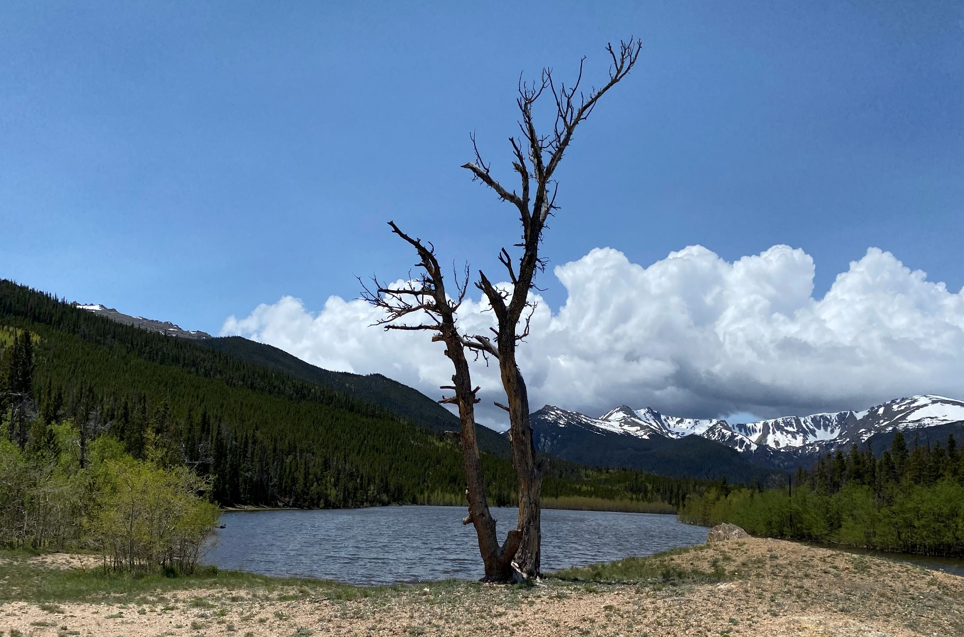

**Photo Courtesy of Dennis Margheim C.W.P.**